eCTF Design Document

Team NEU2

January 31st, 2025

- Overview

This document provides the initial design specifications in compliance with the Mitre’s eCTF 2025 Challenge topology shown below [1]:

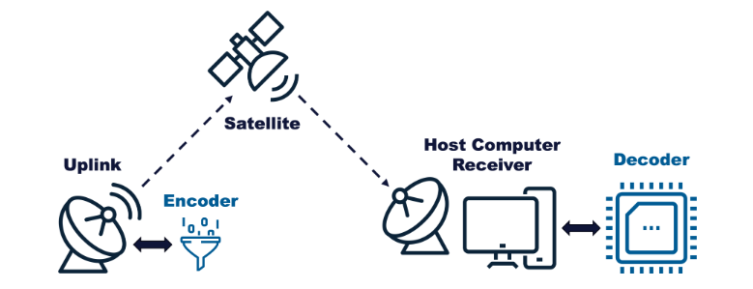

It describes the cryptographic algorithms and mechanisms to be used to support encryption and authentication of subscription information and encoded video frames transmitted from the encoder to the embedded MAX78000FTH-based decoder [3]. This design document leverages some of the mechanisms introduced by industry-grade Real-Time Communications (RTC) protocols for packetization of encrypted and authenticated medio. The Internet Engineering Task Force (IETF) RFC 3711 introduces the Secure Real-time Transport Protocol (SRTP) to support secure video transmission over packet networks [2].

In this context, this document describes a solution that is loosely based on the RFC 3711 standard. While RFC3711 provides encryption, authentication, integrity and replay protection, this document updates the cyber suites to comply with current Federal Information Processing Standards (FIPS) security requirements. In all, these are the features presented in this design specifications:

- Session key derivation based on common crypto secret (as per RFC3711):
  - ${KV}_{e}$: Video Packet Encryption Key
  - ${KV}_{s}$: Video Packet Encryption Salt
  - ${KV}_{a}$: Video Packet Authentication Key
  - ${KS}_{e}$ Subscription Packet Encryption Key
  - ${KS}_{s}$ Subscription Packet Encryption Salt
  - ${KS}_{a}$: Subscription Packet Authentication Key

- Advanced Encryption Standard (AES) 256 Cypher Block Chaining (CBC) for video and subscription packet encryption to introduce control redundancy in the media flow. Initialization Vector (IV) is derived from Device ID and ${KF}_{s}$. Key size: 32 bytes. Block size: 16 bytes. This may be combined with AES-CM as described in RFC3711 to support highest entropy. Note that RFC3711 relies on standard AES-ECB and requires of AES-CM to provide higher entropy. This needs to be evaluated due to performance considerations.

- Secure Hash Algorithm (SHA) 512 for video and subscription packet authentication. Hash size is 64 bytes.

The following sections describe how video and subscription frames are encrypted and authenticated.

- Video Frame Encryption and Authentication

Each actual video frame consists of 8x8 ASCII characters representing a pattern of X and – representing pixels (or 8-bit color pixels). Each video frame is the payload of a header that includes a 32-bit channel number and a 64-bit timestamp as per the diagram shown below:

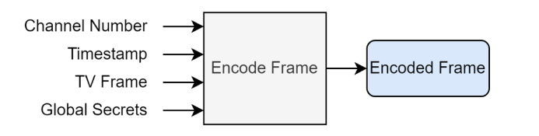

The actual encrypted and authenticated packet must comply with the following structure:
channel id
timestamp
HMAC
video frame
4 8 64 64
encrypted

It includes the following fields:

- 32-bit/4-byte channel number: encrypted by AES-256-CBC/CM scheme.
- 64-bit/8-byte timestamp: encrypted by AES-256-CBC/CM scheme.
- 512-bit/64-byte video frame: encrypted by AES-256-CBC/CM scheme. Padding and/or truncation may be needed to comply with the 16-byte encryption block size.
- 512-bit/64-byte Hash-based Message Authentication Code (HMAC): Authenticates the encrypted section of the packet. It follows the SHA256 scheme indicated above.

Packing, encryption and authentication must be performed by the encoder (or encryptor) in the following python class member in design/ectf25_design/encoder.py

def encode(self, channel: int, frame: bytes, timestamp: int) -> bytes

The pycrypto package supports all needed encryption (AES-256-CBC) and HMAC capabilities (SHA256).

Authentication validation, decryption and unpacking must be performed by the embedded C code in /decoder/src/decoder.c:

int decode(pkt_len_t pkt_len, frame_packet_t *new_frame);

The wolfSSL library supports all needed encryption (AES-256-CBC) and HMAC capabilities (SHA256).

- Subscription Packet Encryption and Authentication

The subscription is based on the generation of a packet that contains the 32-bit device ID, 64-bit start and end timestamps and the 32-bit channel id. The encrypted and authenticated packet must comply with the following structure:

device id
channel id
start timestamp
HMAC
4 8 8 4 64
encrypted
end timestamp

It includes the following fields:

- 32-bit/4-byte channel number: encrypted by AES-256-CBC scheme.
- 64-bit/8-byte start timestamp: encrypted by AES-256-CBC scheme.
- 64-bit/8-byte end timestamp: encrypted by AES-256-CBC scheme.
- 32-bit/4-byte device id: encrypted by AES-256-CBC scheme.
- 512-bit/64-byte Hash-based Message Authentication Code (HMAC): Authenticates the encrypted section of the packet. It follows the SHA256 scheme indicated above.

Packing, encryption and authentication must be performed by the encoder (or encryptor) in the following python class member in design/ectf25_design/gen_subscription.py:

def gen_subscription(secrets: bytes, device_id: int, start: int, end: int, channel: int) -> bytes

The pycrypto package supports all needed encryption (AES-256-CBC) and HMAC capabilities (SHA256).

Authentication validation, decryption and unpacking must be performed by the embedded C code in /decoder/src/decoder.c:

int update_subscription(pkt_len_t pkt_len, subscription_update_packet_t *update);

The WolfSSL library supports all needed encryption (AES-256-CBC) and HMAC capabilities (SHA256).

- Security Considerations

  - Session Key Derivation

Session key derivation will follow the approach specified in Section 4.3.1 of the SRTP RFC3711 specifications. Because the crypto secret is negotiated over the Session Initialization Protocol (SIP) as opposed as provided as a common secret independently in the encoder and decoder some minor modifications are needed. Also, this prevents re-keying which is not possible due to the lack of real-time communication between encoder/encryptor and decoder/decryptor.

For both video and subscription packets, the encryption keys (${KV}_{e}$ and ${KS}_{e}$) are 256 bit long to support AES-256. The encryption salts (${KV}_{s}$ and ${KS}_{s}$) are 128 bit long to support the IV in CBC/CM modes. The authentication keys (${KV}_{a}$ and ${KS}_{a}$) are 256 bit long to support HMAC randomization.

The common secret encoded as a base64 string, encodes a 36-byte pseudo random number that is decomposed into a 14-byte Master Salt and a 32-byte Master Key which derives the sessions keys. Video packet session keys are derived as SRTP session keys while subscription packet session keys are derived as SRTCP session keys as described in RFC3711.

  - Packet Encryption

Packet encryption is based on AES-256-CBC encryption where the IV is computed based on the session encryption salt and the device id (for subscription packets) and channel id (for video packets).

AES-256-CBC is used to encrypt the session encryption key which in turn sequentially XORed with the contents of the packet as per CM encoding in RFC3711.

While RFC3711 relies on AES-128-ECB for encryption, this document introduces AES-256-CBC to provide stronger resilience against attacks.

  - Packet Authentication

Packet authentication is based on the generation of a 512-bit HMAC that is computing from performing SHA512 hashing on the data structure that combines the actual encrypted packet data and the 256-bit session authentication key.

- Compliance with Security Requirements

While the sections above cover the functional requirements, the compliance with specific security requirements are described in this section.

  - Security Requirement 1

An attacker should not be able to decode TV frames without a Decoder that has a valid, active subscription to that channel.

This will be implemented in the aforementioned device decoder function, where incoming video packets after authentication validation and decryption will be checked to make sure that the channel id is one in the subscription list. Video frames associated with channel 0 will bypass this checking.

  - Security Requirement 2

The Decoder should only decode valid TV frames generated by the Satellite System the Decoder was provisioned for.

This will be enforced by supporting authentication by means of HMAC tags in all packets. This not only applies to TV frames but also to subscription packets.

  - Security Requirement 3

The Decoder should only decode frames with strictly monotonically increasing timestamps.

As for requirement 1, this will be implemented in the device decoder function, where incoming video packets after authentication validation and decryption will be checked to make sure that the timestamp complies with this requirement. A basic playout buffer scheme (similar to that used in RTC system) would work in this case. Note that in combination with the security considerations presented in this document, replay protection will be also implemented.

- References

- Mitre’s eCTF Rules, https://ectfmitre.gitlab.io/ectf-website/index.html
- IETF RFC3711, The Secure Real-time Transport Protocol (SRTP), https://ectfmitre.gitlab.io/ectf-website/index.html
- Analog Devices, MAX78000FTHR, https://www.analog.com/en/resources/evaluation-hardware-and-software/evaluation-boards-kits/max78000fthr.html

